***Contact Us – Page***

**Members:**

Shreya Tandale (61)

Urmila Salgar (45)

Sanjivani Singh (56)

Utkarsh Mishra (26)

***INDEX***

I. Introduction

II. Flow of the project

III. Implimentation Screenshot

IV. Future Scope

V. Conclusion

VI. Reference

***INTRODUCTION***

It Automatically import contacts from your SQL database into your Mailify contact lists.

To do this, first create a new synchronized list.

You will then be able to select the "MySQL/SQL Server" connector.

Then, enter the settings of your SQL server. Find this information with your webmaster or host.

Once the accesses to your SQL server have been configured and the SQL table you want to synchronize is defined, a list will be created.

The burger menu at the end of the line allows you to access a number of actions regarding your list.

* **See:** Allows you to view your list in read-only mode. It will not be possible to edit your list from this screen, as it has not been created manually on Mailify Sunrise, and it is connected to a remote database.
* **Create a campaign:** Allows you to start creating a campaign (email, sms, or automatic). The contacts in your list will be loaded as recipients of your campaign. It is important to note that, in the event that contacts are added to your SQL synchronized list in the meantime, they will not be included in your campaign's mailing list later on.
* **Properties:** Allows you to access the properties of your list. The name of the list can be modified. You can also determine your sharing settings from this screen (i.e. determine with which other users you want to share this list). You can also change the connection settings to your SQL server if they have changed.
* **Programming:** This action allows you to program a frequency at which you want our services to "retrieve" the information from your SQL table to update the corresponding contact list on your Mailify Sunrise interface.  
    
  You can define an automatic hourly, daily, weekly or monthly update frequency.  
    
  You are free to configure your programming as you wish. By default, no automatic update is set. This means that the refreshing of your list must be done by manual action from your side.
* **Benefits of Contact Us Page**

*Group your contacts into categories:*

* You can group your contacts into categories like a new customer, returning customer, loyal customer, and past customer. This will help you to understand their purchasing behavior and preferences.
* Now you can plan different sales strategies for each group and send regular promotional offers and discounts. You can also tag contacts to indicate the level of interaction you had with them.

*Save time with the Search and Filter option:*

* The Search and Filter feature assists you to locate contacts by specific details like name, location, organization name, etc.
* Normally you would have to search your entire contact list for example - to find the right customers before sending emails or making follow-up calls. Now you can easily use the Search and Filter option and search the contact in a few minutes and complete your work quickly.

*Import and export contacts quickly:*

* Import a list of contacts quickly from other locations like spreadsheets or Google Contacts. And you can also export contacts in multiple file formats to excel sheets, to another Contact Management System, or even make it printable. You can save time by importing and exporting the bulk of contacts.

*Integrates with your commonly used apps:*

* Contact Us Page easily integrates with other commonly used applications like [Gmail](https://www.gmail.com/), [Skype](https://www.skype.com/en/), and [Slack](https://slack.com/intl/en-in/). It pulls out contact information from these apps and adds it to your contact list.
* All details of your contacts will be linked and archived automatically and it can be retrieved whenever you need it. As adding contacts is done by Contact Management System you save time because there is no manual work and problems caused by human error are also eliminated

*Add relevant notes to contacts:*

* You can also add notes to each contact for the reference. You can refer to these details and if it is shared with others, it is easier for them to refer to that detail.

*Store your contacts in the cloud-based system:*

* The Contact Us Page is cloud-based and all information about your contacts, like name, address, phone number, call log, email address, and details of interactions are stored safely. Being cloud-based it allows anyone from your organization to view and update contact information from anywhere with an internet-enabled device.
* You will be able to view the updated contact information immediately, as soon as it is done. This is very helpful when your workforce is distributed in more than one location. You can eliminate data loss as all information is stored in the cloud.

***Flow of the project***

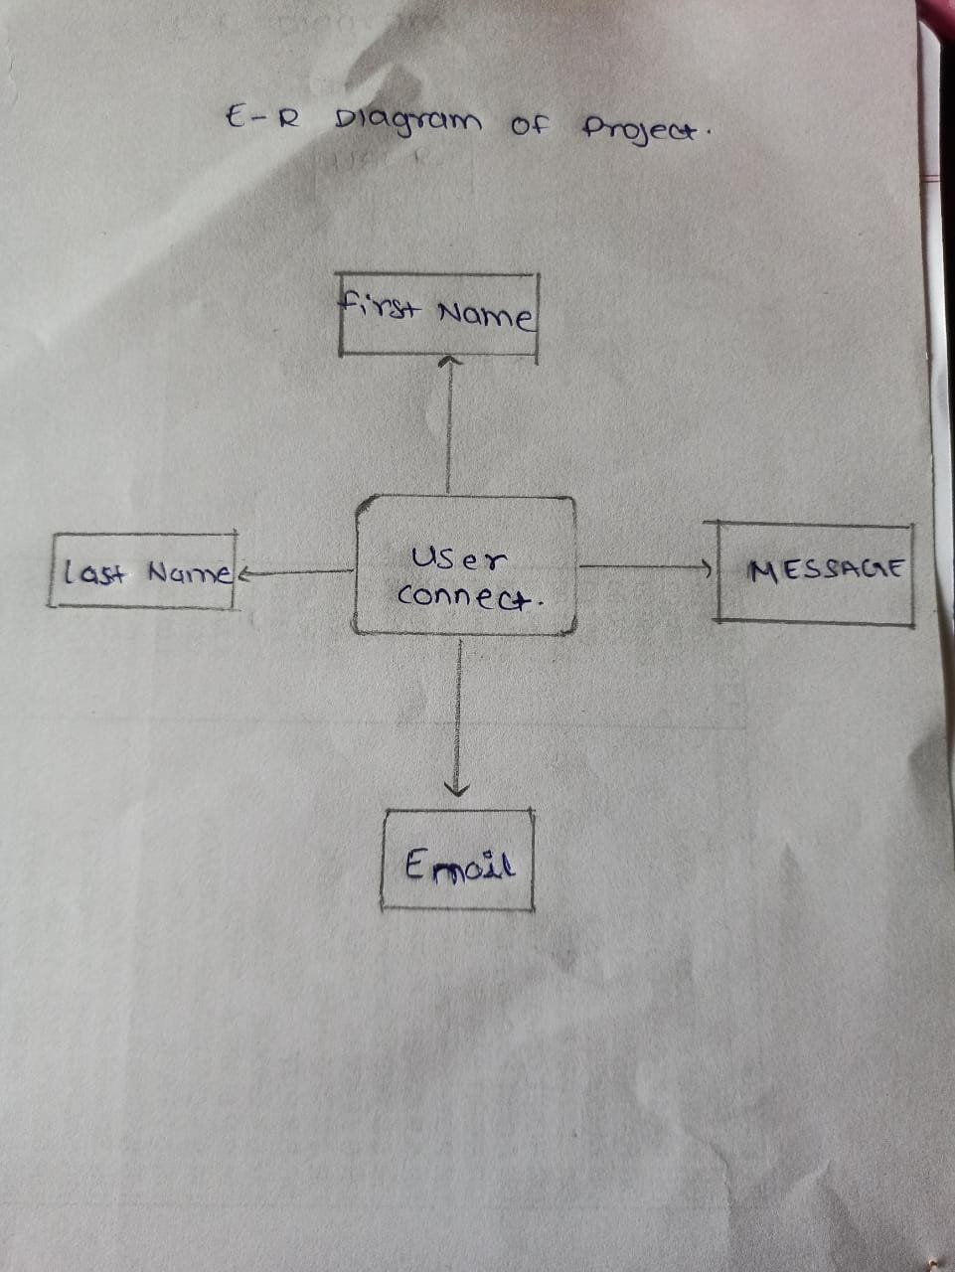

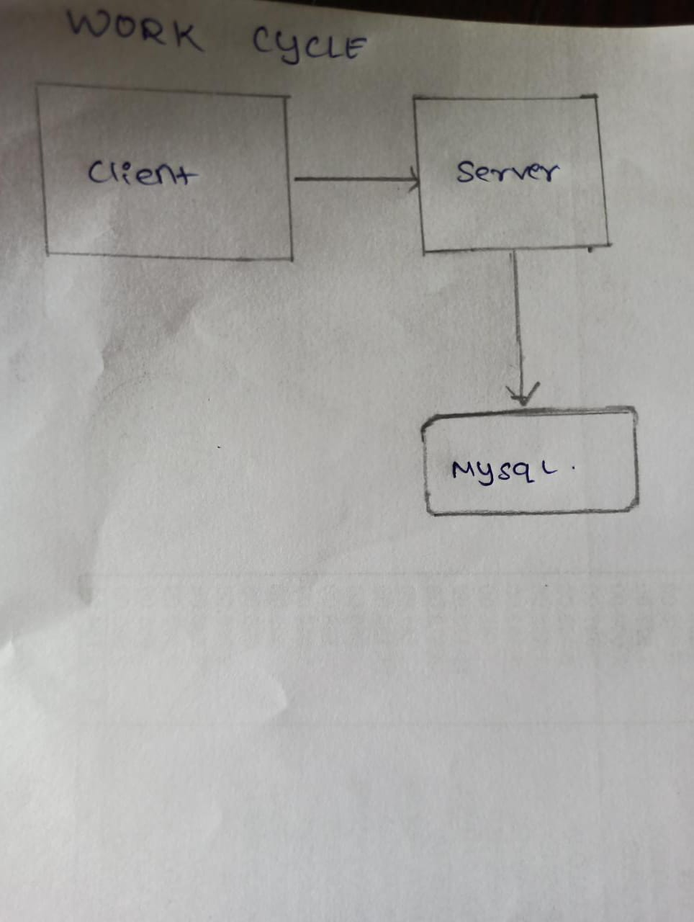

***Implementation Screenshot***

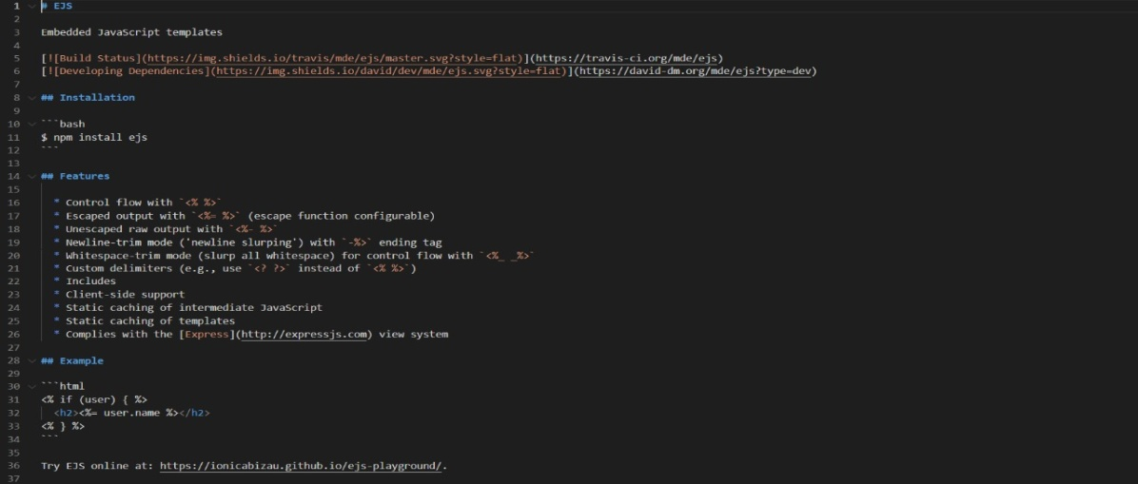

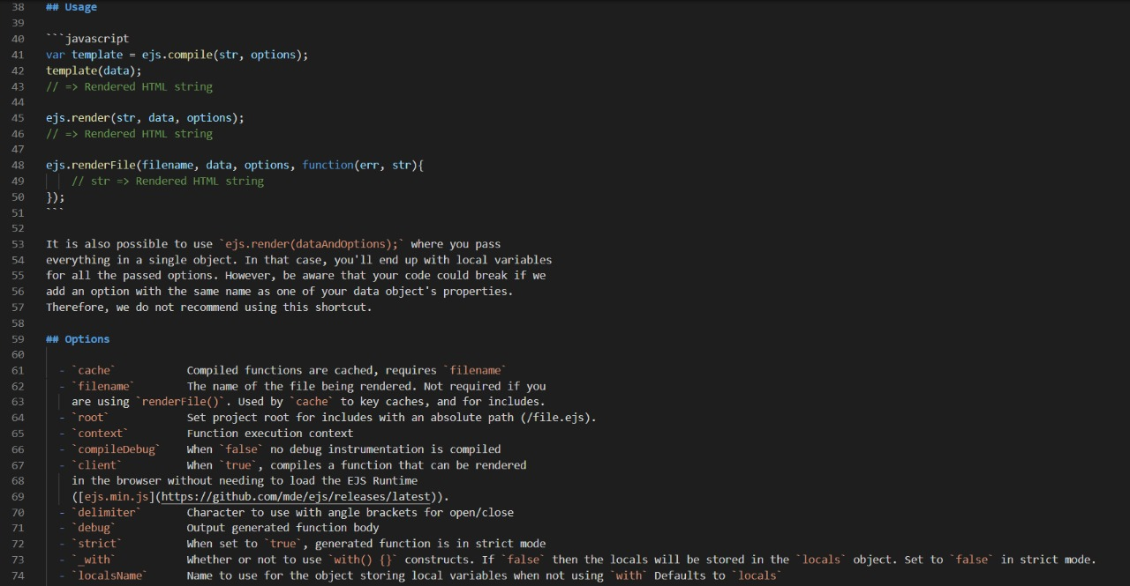



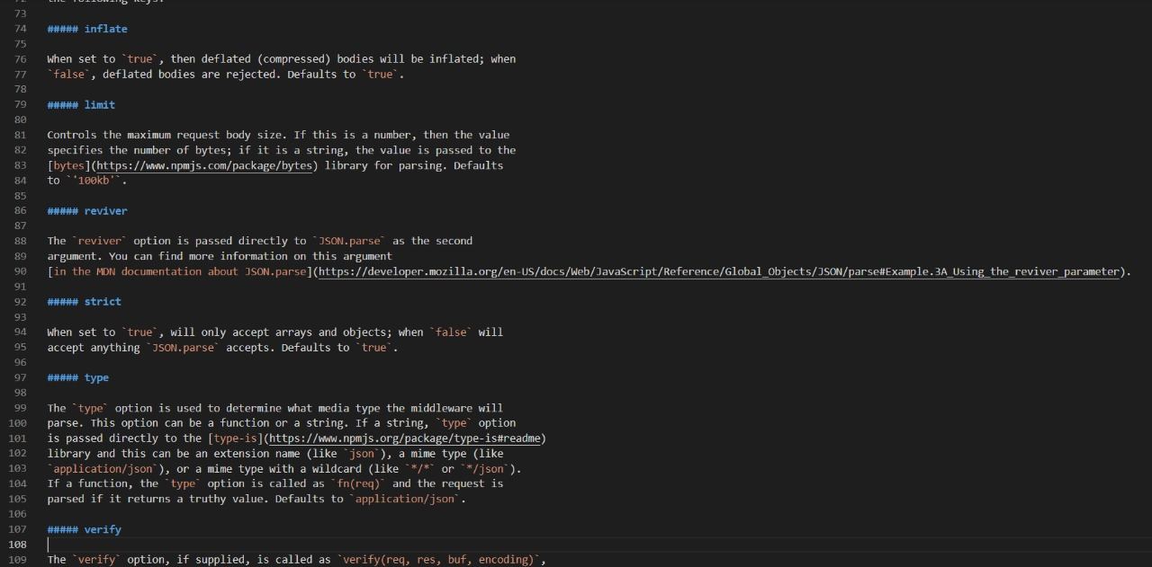



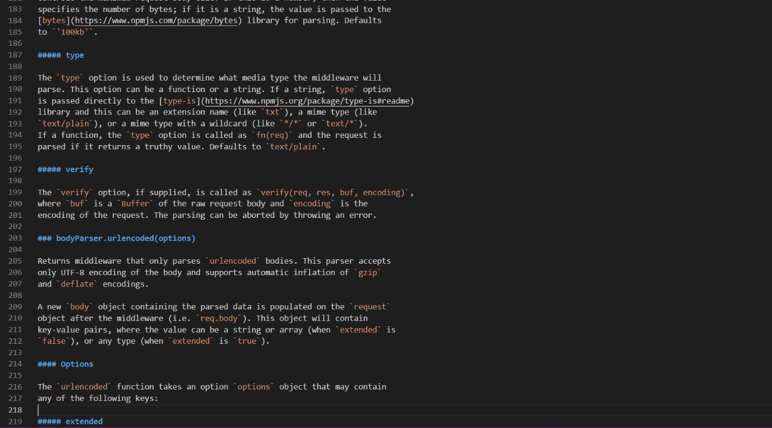

***Future Scope***

SQL is a massive technology. The future scope of being an SQL Developer it is not just limited to Computer Science, but you can see it revolving around Retail, Finance, Healthcare, Science & Technology, Public Sector, in short everywhere. All organizations need a database for the storage of their data. There are endless reasons why you could SQL career. A few are listed below:

* **Combine data from multiple resources**: Integrating data from several resources may be consuming a lot of time, but with SQL, you may simply combine the specific fields or merge the complete database.
* **Everlasting:** The image below shows a report of StackOverflow’s survey conducted in 2017  where SQL stands second in terms of popularity ensuring that SQL is here to stay for times to come.
* **Free:** SQL is open-source which means that SQL is completely free to use and distribute. As far as learning is concerned, you just have to bear the initial training charges of SQL certification, later on, you need not pay for any tool or software to practice SQL. SQL is executed using XAMP/WAMP server, which is an open-source tool for executing the queries.
* **High in Demand**: If you search the internet for jobs for SQL Developers, there are more than 25k results. According to an analysis, SQL has been mentioned in 35.7% of advertisements, which is 1.39 times higher than the advertisements of Python and other Data Analytical languages.
* **Integration**: You can utilize SQL queries with the incorporation of other programming languages like PHP or Java depending as per your requirement.
* **Manage bulk of data:** When you have a large collection of data, then it becomes really difficult for the conventional database software to manage them. In this case, SQL acts as a blessing. Whether there are a thousand records or a million, SQL is fully equipped to manage a huge amount of data of all types.
* **Simple:** SQL is the simplest programming language as compared to its contemporaries. One can easily learn the basics and fundamentals of SQL within a week or two.
* **Standard:** SQL development has been around for 30 years now and without any doubt, it is going to stay for a good 30 years or more too staying true to the old proverb, “Old is Gold”.
* **The base of data visualization tools**: All data visualization tools utilize SQL for their functioning. Therefore learning SQL will help you get a better understanding of all such tools.

***CONCLUSION***

Contact Us Page gives you easy access to all details regarding your contacts. Being cloud-based it enables you to share the stored information easily with your team which boosts the productivity of your organization.

Also, SQL Developers are sought after because of the expanding dependence on the information. Turning into a SQL engineer can be a fulfilling and satisfying vocation. The path towards it is generally simply contrasted with other specialized vocations. Microsoft SQL Server is among the best 3 RDBMS frameworks and getting the right skills for turning into a SQL Server developer will work well for you and open many job opportunities.

Most SQL developers are either database specialists or veterans in managing database advancement. There are various kinds of SQL relying upon the stage you use, however, they all play out similar essential capacities—recover, include, alter, and erase database information.

***Reference***

Feature of Github with coming soon page:

https://github.com/features/codesspaces/signup